CLASSIC YACHT HELENE

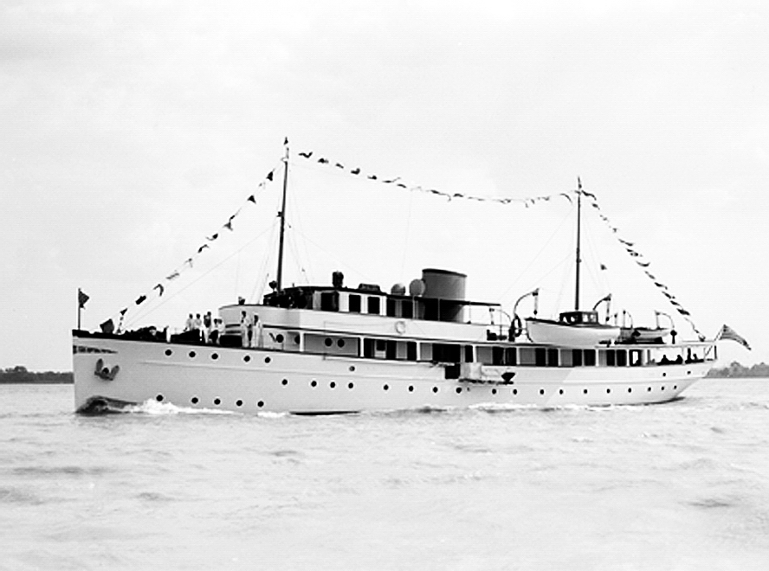

HULL #140 HELENE Built by the Bath Iron Works

T.S.Diesel Yacht for Charles E. Sorensen, Vice President of Ford Motor Co.

146'- 4"long, 24'-10"beam, 14'- 3"depth, 8'- 6"draft, displacement 345 tons light ship, 371 tons full load, Twin Cooper Bessemer diesel engines, 800 horsepower each. Keel laid August 1,1930, launched April 18,1931, delivered May 15,1931. Commandeered by the United States Army Corps of Engineers in 1940 and renamed CAVANAUGH, Served as a patrol ship in World War II. When the war ended, Sorensen refused to accept the post war condition of the yacht and she was sold.

Interior Photographs

Fireplace in the main Salon

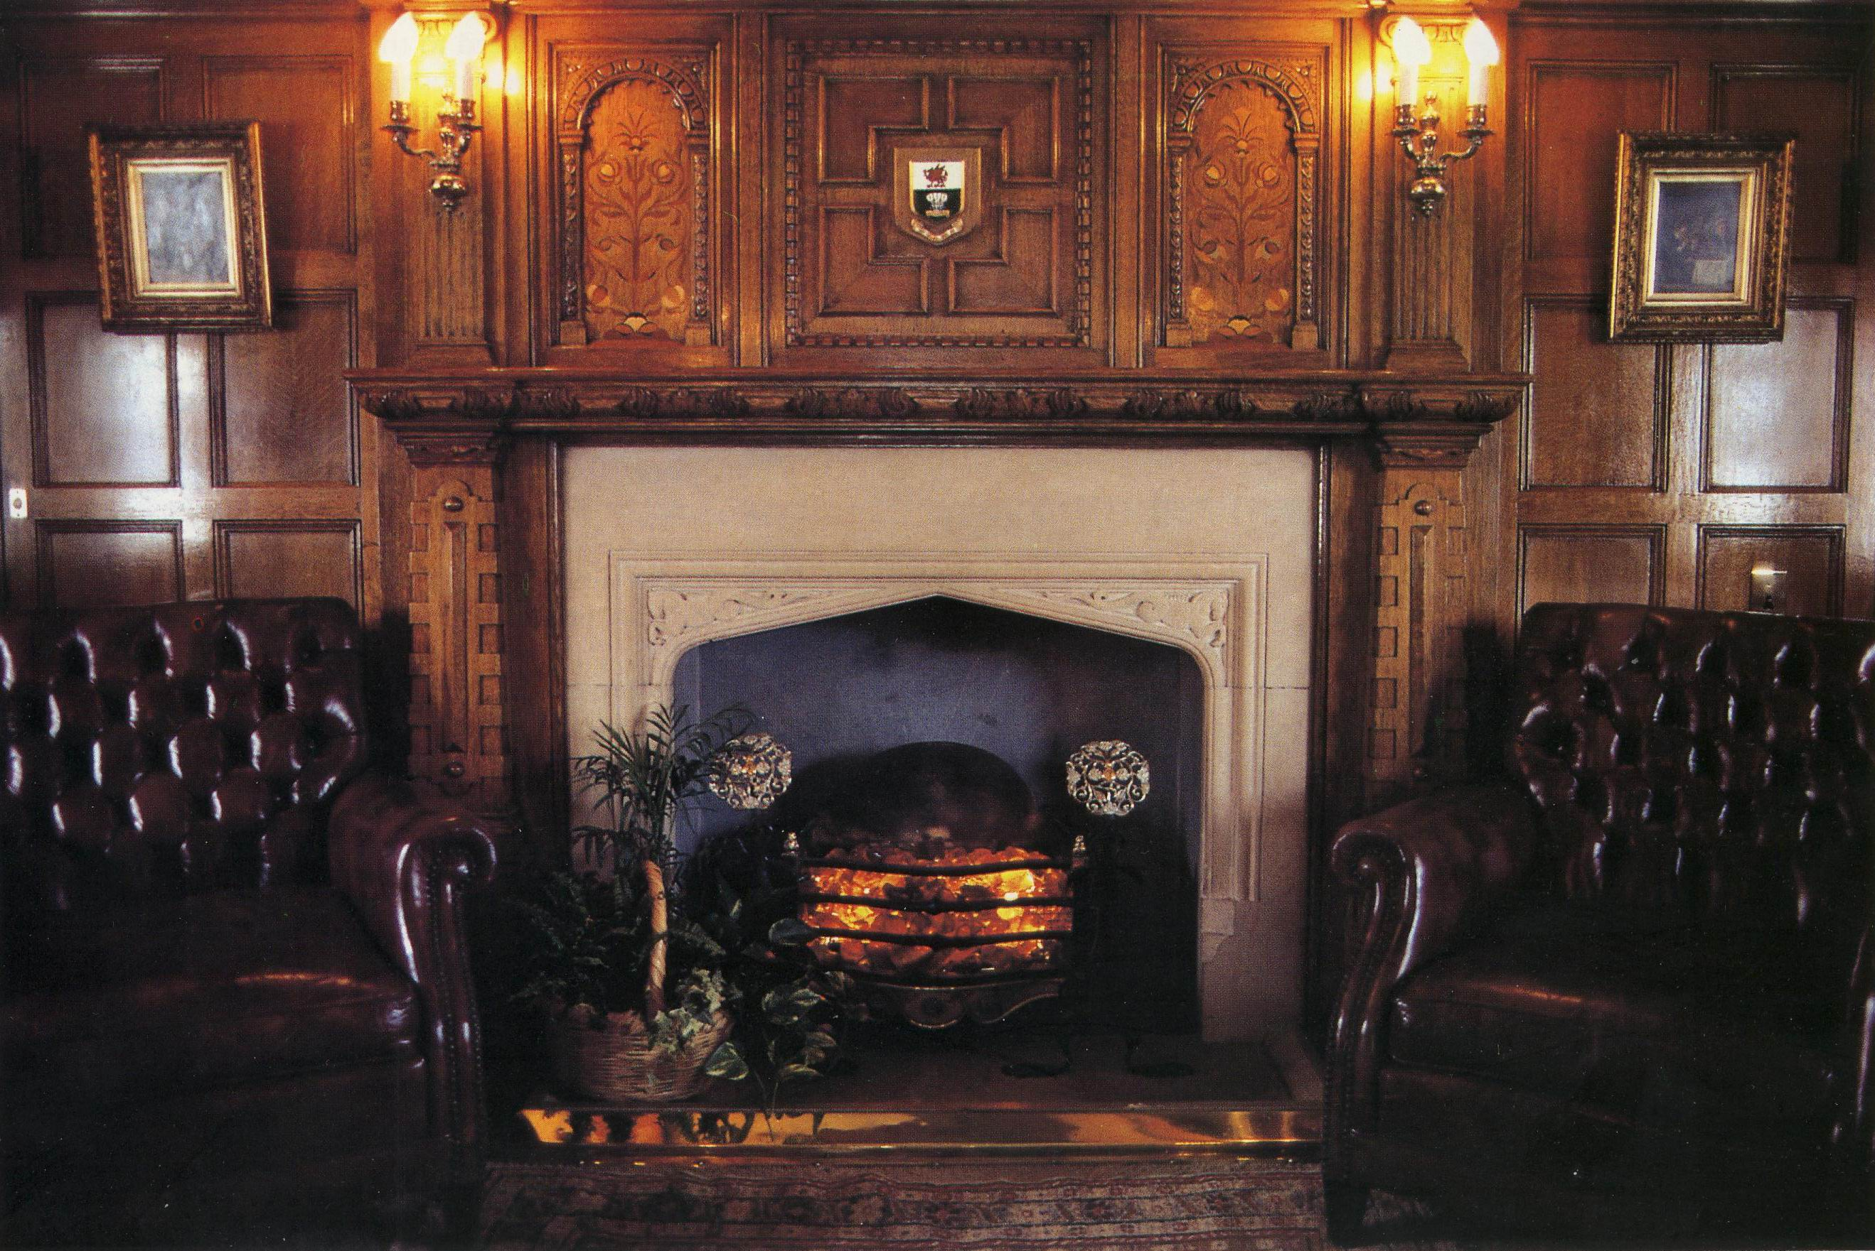

Formal Dining Salon

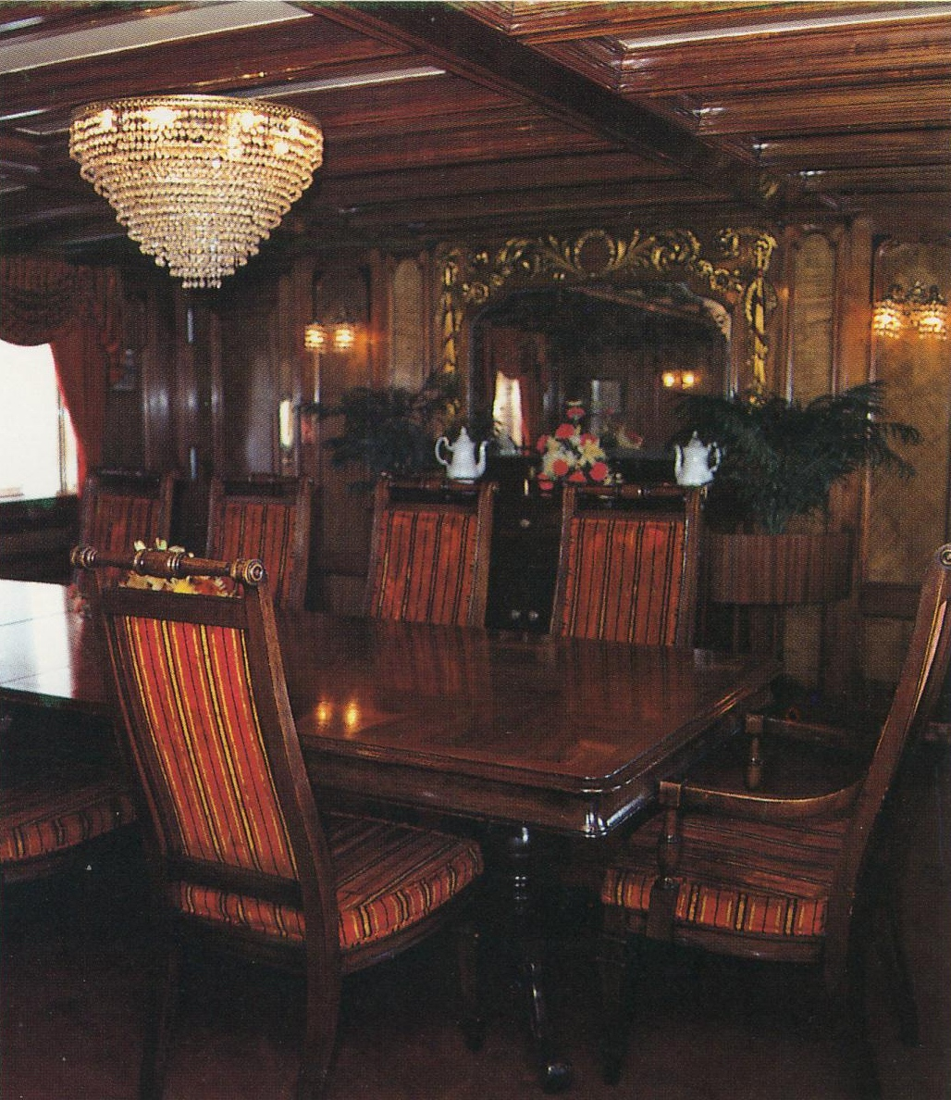

Bar

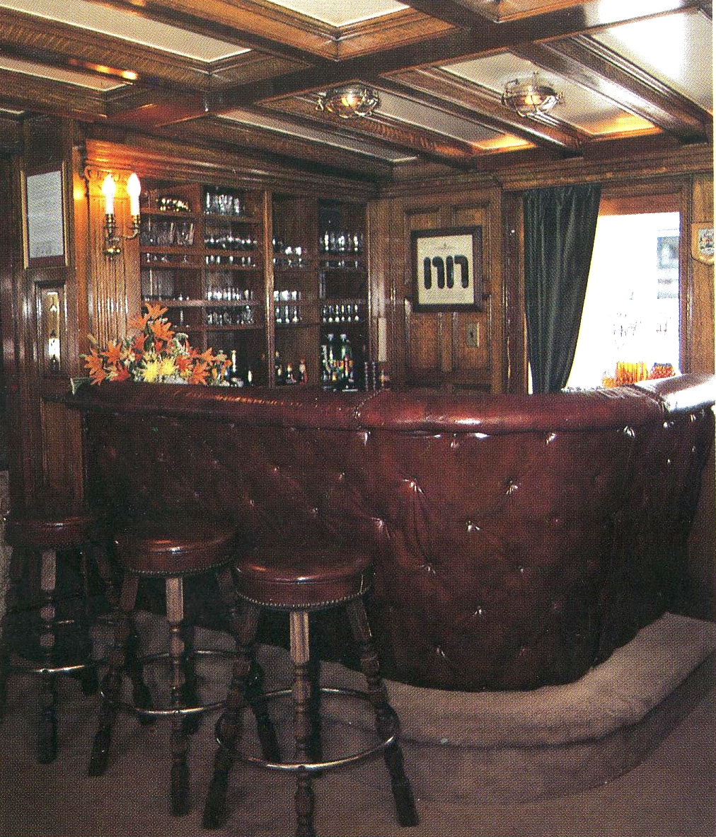

Companion Way

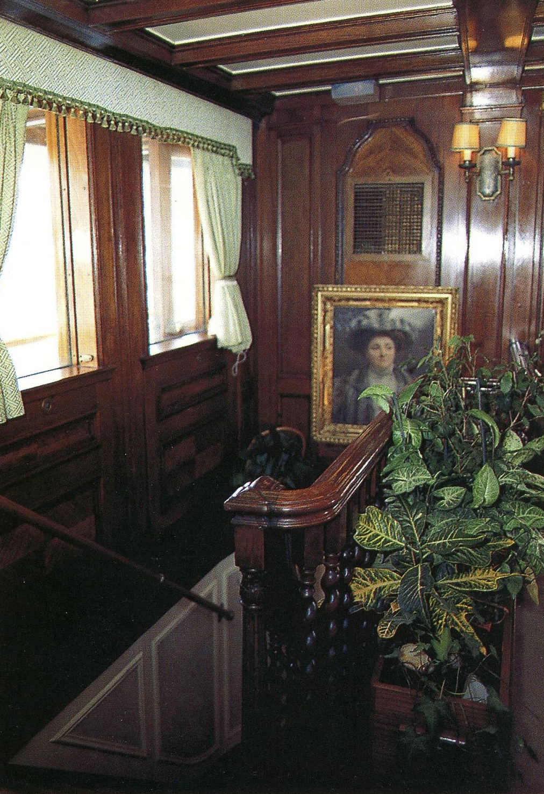

Main Salon

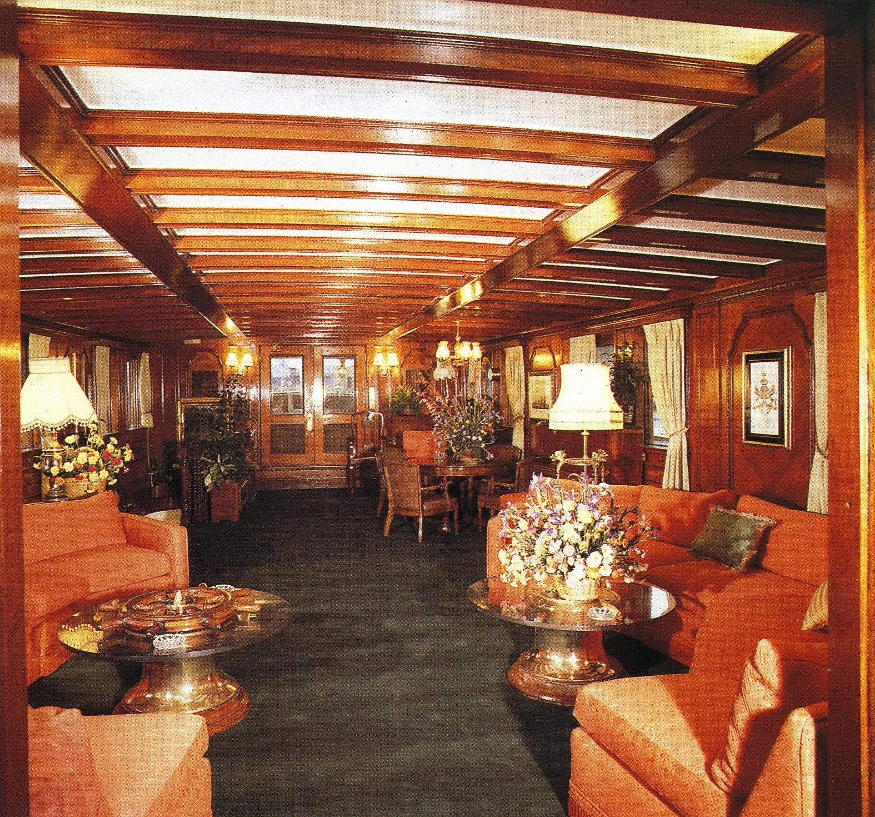

Master Stateroom

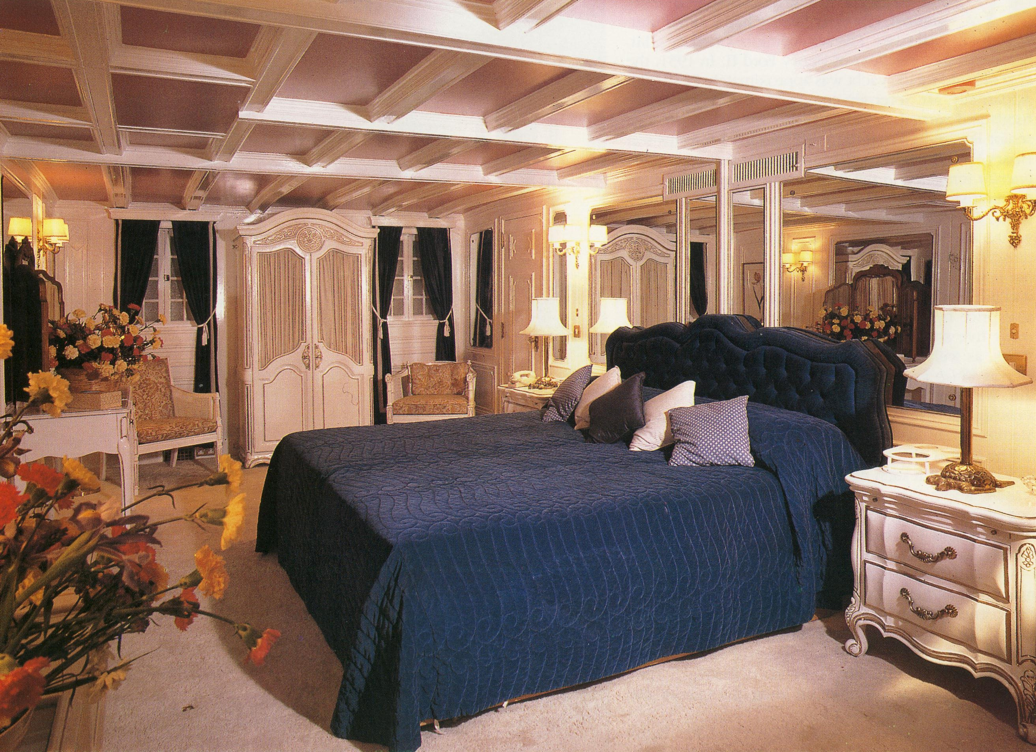

The second owner retained the name CAVANAUGH, and the third owner re-named her CARONIA. She spent most of her years in the Southern California waters of North America and was eventually sold a fourth time to a European Charter company and renamed WELCH PRINCESS.

While under the ownership of DRAGON YACHTS, the WELCH PRINCESS was re powered with Cummins diesel engines and in an effort to modernize her appearance was fitted with a flared bow extension and other cosmetic enhancements.

Photograph of WELCH PRINCESS taken in the Thames River in the early 1980’s

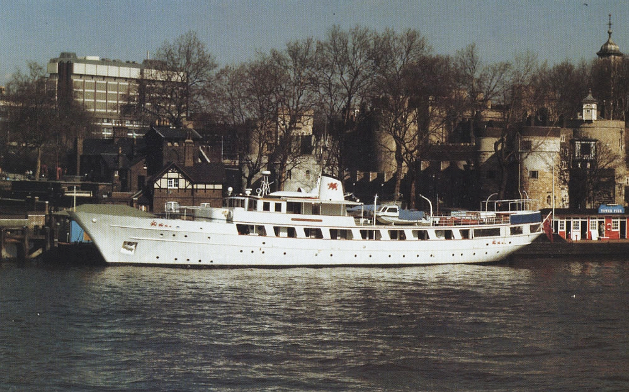

On July 7th, 1989 she developed a fire in the engine room while en route to Cardiff, Wales and sank in approaches to the English Channel in 93 fathoms (558’) of water. Her final resting place is 49°07'94”N: 04°22'08” W Approximately 25 nautical miles North of the coast of France

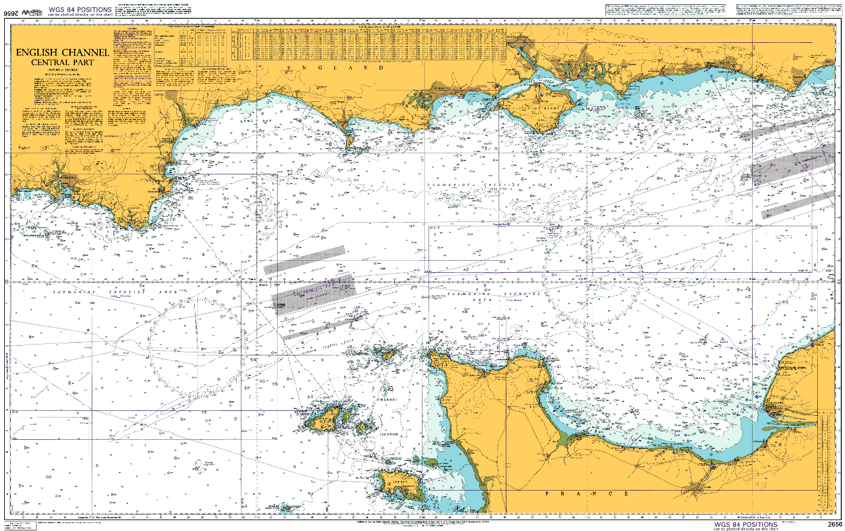

End
